Games Development Game Engine 2 Project
Minor Inconvenience League

BSc (Hons) Computer Games Development
Lecturer: Marco Gilardi

Table of Contents
Project Plan:
Team List + Roles
Project Details
Game Genre Research
Development Details

Game Overview:
Narrative
Objective(s)
Playable Characters
Enemies
Firearms
Level(s)
Level Layout
Game Modes

Project Plan:

Team List + Roles:
Evan Montgomery – Lead Artist
Emilia Gibson – Lead Writer (Documents/Game narrative)
Lyall McClue – Lead Level Designer
Andrew Forrest – Lead Programmer

Additionally, all of us will be working on searching for and verifying what assets we plan to/want to use for our game.

Project Details:
Project Necrosis is a 3d FPS zombie survival game that is to be developed in the unity engine by our 4 team members with the goal being to either escape the facility in the quest mode or simply survive in the survival mode, with the traditional mechanics of both an FPS game but also zombie survival games like Cod Zombie’s and Left 4 dead being incorporated into its gameplay loop.

We aim to have a good variety of content in the game but also to keep our expectations in check for the time frame we must develop it while also working on other course work for the Uni.

Game Genre Research:

Development Details:
We aim to develop this game purely on the Unity engine using it’s 6.0 version, with development being singled down for a purely PC market removing the workload that would be needed for the game to work on consoles, other software we plan to use includes Adobe Illustrator for original graphics and Blender if we want to make any original 3d models.

Game Overview:

Narrative:
Set in the late 70s, the players will be investigating a allegedly Soviet owned Biopreparat (Biological warfare) facility in South East Asia allegedly testing the titular Project Necrosis, a bioweapon said to raise the dead, and after raiding and killing the guards and operatives in the facility it turns out this goes far deeper then command or the ops expected, leading to needing to hold out against both the dead and invading operatives of Grupp stell (temp name), a Soviet backed research group working on the weapon.

Objective(s):
Survive to a select wave and call-in backup to evac in the quest mode with the potential you could be an optional way to get a good/bad ending by creating an antidote.

Playable Characters:
Wolfgang Steiner:
An East German defector who specialises in recon duties, Wolfgang is an extremely cold and distant character who makes blunt and literal remarks every time he is given a chance to speak for his quotes, with his visual appearance reflecting his recon role by being something resembling a ghillie suit, or at the minimum having much more camo than the others and hiding his face behind it.
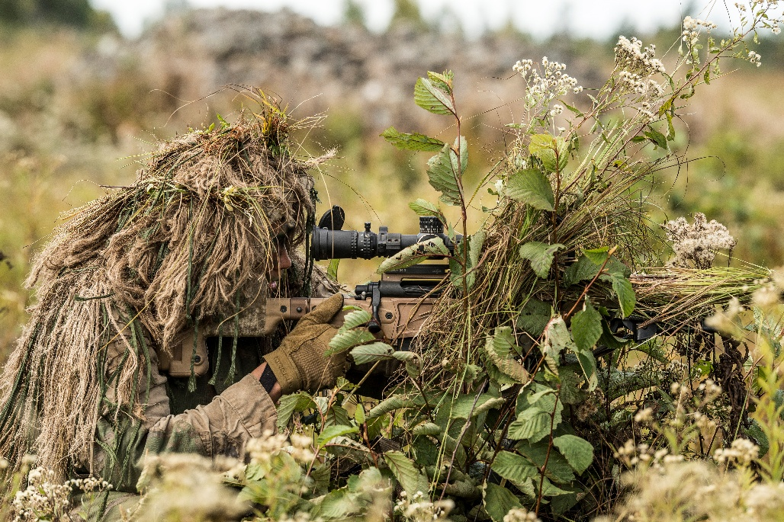
Arthur ????:
????
????

Game Mechanics:

Control’s:
In game the player will use the WASD keys to move in the appropriate direction of the key they pressed ala W for up and S for down and while moving they can hold down shift to begin to sprint, though sprinting stops the player being able to shoot unless they own the correct perk to let them do this.
The camera is moved by the mouse and matches the direction that the mouse is currently looking at ala if looking right so will the camera.

The player can interact with interactable with the E key, which will include things like wall buys, doors, perks and the weapon chest/upgrade kits, if they have the right points this will then make a purchase, if otherwise it’ll do nothing

When ESC is pressed the game is paused and will be until ESC is pressed again or the player clicks resume.

The player can fire their gun with the right click of the mouse, either being able to hold down for continuous fire with a full auto weapon or needing to click again for a semi auto and can reload the firearm at any point when it misses 1 bullet in it’s starting mag by pressing R or automatically reloading when the mag runs empty.

Perks:
In the game space the player will be able to find perk machines at set locations, with each perk offering a unique benefit to the player if bought, with each one’s cost reflecting what it does to help benefit the player in game.

Death’s Door Tonic – For 500 points in solo, or 1500 in MP, the player is granted increased healing speeds, quicker revives for multiplayer and a self-revive in solo, which is capped at 3, as once this cap is hit the machine will become unusable to the player.

Tough’N’Up Soda – For 2500 points, the player is granted additional HP that enhances their durability against enemies.

Quick’N’Up Brandy – For 3000 points, the player will gain the ability to reload faster, to move faster and to be able to sprint and shoot/reload with no draw backs

Spray’N’Pray Root beer – For 2000 points, the player will gain additional damage for their bullet-based firearms by around 5-10%, as well as the fire rate being slightly upped for all firearms.

Each one has its own unique benefits to the player as observed above and the machines will be easily recognised by the name and logos used for the machine that tell the player instantly what it is.

Enemies:
Zombie: Most numerous enemies fought in the game, they operate under the same logic as classic Romero style zombies in being slow moving and only using melee to hit the player, which makes them easy to take down on their own, but with numbers they become much more dangerous to the player.

Fast Zombie: Introduced starting from round 4, the fast zombies begin to slowly be worked into the enemy spawn pool until they outnumber the basic zombie, dealing the same damage as the normal but them being faster brings a much greater threat to the player than the normal one’s do.
Biopreparat Grupp soldier: Special enemy that only appears every 5 rounds, they are humans with gas masks who enter the facility in an attempt to stop the player cast, they are the only enemies who use ranged combat which makes them a greater threat at range then the zombies are, but they are much squishier than the zombies and die quicker to compensate.

Firearms:
Two distinct sets of weapons focusing on Western and Eastern weapons include in the firearms pool, with one side being mainly Western and the other Eastern, with the players all spawning with a M1911 at game spawn but quickly getting options to upgrade their gun from wall guns or from the interdimensional crate (box) and able to use upgrade kits in the upgrade facility to upgrade their firearms (pack a punch)

Example firearms include:
Pistols – M1911 and Makarov
Revolver – Python and Nagant M1895
AR – M16A1 and AKM
SMG – MP5 and PPSH-41
Shotgun – M37 and KS-23
Semi auto rifle – M14 and SKS
Sniper – M40 and Mosin-Nagant
Semi auto sniper – PSG1 and Dragunov
Launcher – M72 LAW and RPG-7

Each weapon will also get a unique name when it’s put into the upgrade machine and depending on the firearm will gain a new unique property for shooting, as an example when the M1911 is upgraded it becomes Duty and Honour, changing to a akimbo firearm that shoots grenades instead of the normal bullets it started with, meanwhile the PPSH-41 will become the Stalingrad Sweeper and have its fire rate upped even further than it already is while it gain’s a drum magazine with an impressive amount of ammo to keep up with its blistering fire rate.

Level:
There is a singular main level in the game, being Operation Necrosis which will feature the full map with all of its narrative mechanics included within, with 2 main areas of note to be explored in the map being the village at spawn and the facility, with a jungle connecting the two player spaces to one another to reflect the Southeast Asian setting of the game

Level Layout:
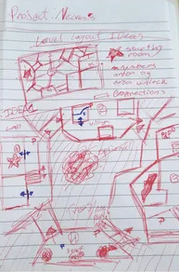

Game Mode:
Quest mode is exactly what it says on the tin, a narrative focused experience where a set story will be explored following a cast of 4 characters who must survive against all odds on their own against the dead featuring the full map to explore.

Visual Aesthetics:
The game has an overall realistic approach to its appearance reflecting it taking place in our world in a historical setting, with both the environment and the characters within being made to feel like they could have believably existed in this time and place.

Due to being set in the rural jungles of Southeast Asia, the game will reflect the setting in the village and the jungle that connects it to the main base with local architecture and vegetation.
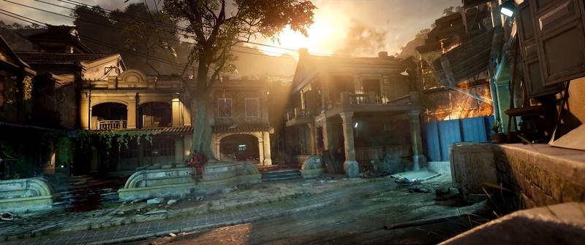

Meanwhile the facility will be much more cold and general purpose to reflect its artificial and recent nature having only been created 2-3 years before by Grupp Stelle, with various bloodied medical tools and furniture littering the facility alongside bureaucratic papers and research labs, making for a vastly different vibe to the previous two areas which is punctuated by the Russian words littering the walls of the facility, the Gruppe Stelle logo as well as propaganda.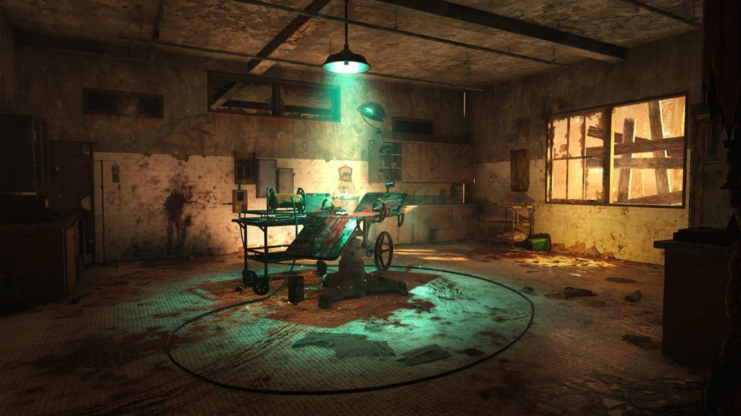

HUD:
Like Black ops 3 zombies, shows as minimal information as possible, with the left containing the round counter, points, and perks and the right the guns name and the ammo count in the current mag/reserves
